WWGM CAD 3P Log Browser
Feature Specification &
Claude Code Implementation Guide
WinForms / C# / .NET • Internal Team Distribution • Portable Deployment

79  Total Features | 25  From Original Spec | 14  Updated from Notes | 40  New Additions

Application UI Design Reference
The screenshots below show the actual working application and the intended UI design for enhanced features. All feature specifications in this document must conform to these designs.

Menu Bar Structure
File | Edit | Options | View | Help

FILE EDIT OPTIONS VIEW HELP
Open... (PTC_LOG_DIR) Copy (ENTER→EXIT) Settings Show Call Tree (toggle) Help CHM (F1)
Save Selected... Find (Ctrl+F) Show API Tree (toggle) About
Save to XLS... Find Next (F3) Hide Tabs Check for Updates
────────────── Filter... Show Tabs Report Errors...
Reload from Disk Expand All ──────────────
────────────── Collapse All Log View
Recent Files ► Jump to Matching ENTER Performance View
────────────── ────────────── Call Graph
Exit ...

Default View (Call Tree + LogText Tab)
Left panel: Call Tree with checkmark (✓) or cross (✗) icons per node. Right panel: tabs — LogText (default), Performance, RPC, LogEditor. LogText tab shows two columns: line number and log text.
Title bar: WWGM CAD 3P Log Browser = [full log file path]

┌─ Left Panel (Call Tree) ─────────────┬─ Right Panel (Tab View) ──────────────────────────┐
│ ☑ Call - Tree │ [LogText] [Performance] [RPC] [LogEditor] │
│ ⊞ ✓ ugadapter_app::startup │ │
│ ⊞ ✓ IdleCommandsQuery::execute... │ Line# │ Log Text │
│ ⊞ ✓ uwgmCadAdapterHandler::han... │ 866 │ 2026-04-02T15:33:24... idle lcubed ... │
│ ⊟ ✓ uWGMCADSystem... openAndS... │ 867 │ 2026-04-02T15:34:10... UWGM_ADAPTER... │
│ ⊞ ✓ uwgmSessionNDManager::... │ 868 │ 2026-04-02T15:34:10... [selected, highlighted]│
│ ✓ CADSystemUnigraphics::... │ 869 │ 2026-04-02T15:34:10... UWGM_ADAPTER... │
│ ✓ CADSystemUnigraphics::... │ ... │
└──────────────────────────────────────┴────────────────────────────────────────────────────┘

Node icons: ✓ = ENTER/EXIT pair matched correctly ✗ = ENTER/EXIT pair incomplete or missing
Log view: Clicking a tree node scrolls to that line + shows 10 previous lines
Highlight: Selected line highlighted in colour defined in Settings

API Tree View
The API Tree shows one flat level of unique API names as root nodes. Child nodes represent each individual invocation, labelled as 'API name — Line No'.
┌─ Left Panel (API Tree) ──────────────────────────────────────────┐
│ ☑ API - Tree │
│ ✓ CADMigrationHelper::initMigrationPrepSocketStreams │
│ ✓ CADSystemUnigraphics::addGenericNameAttribute │
│ ✓ CADSystemUnigraphics::addWLDInSearchPathDirectory │
│ ⊞ ✓ CADSystemUnigraphics::closeDocument (expand for calls)│
│ ✓ CADSystemUnigraphics::closeDocument — Line 1042 │
│ ✓ CADSystemUnigraphics::closeDocument — Line 2891 │
│ ⊞ ✓ CADSystemUnigraphics::connect │
│ ⊞ ✓ CADSystemUnigraphics::createCADModel │
│ ... │
└──────────────────────────────────────────────────────────────────┘

Performance Tab
The Performance tab (right panel) shows a grid with the columns below, sortable by clicking any column header. The 'Self Time' column shows time spent within the method excluding child calls.
Columns: Method Name | No of Calls | Time | Max Time | Min Time | Average Time | Total Time | Self Time

Example rows (sorted by Total Time descending):
CADSystemUnigraphics::setReadOnlyStatus 670 1980616 67266 0 2956 1980616 (self time)
CADSystemUnigraphics::flushInstanceToDisk 162 1678449 34578 2334 10360 1678449
NXOpen::Part::Save 162 175312 2076 506 1082 175312

Click column header → sort ascending. Click again → sort descending.

Filter Log Dialog
Filter Log [X]
──────────────────────────────
Filter Log Entries
[________________ ▼] [Add]

OpenFired
SaveFired
ProcessMessages
(list of active filter terms)

[Remove] [Remove All] [Filter] [Close]

Behaviour: user types a method name, clicks Add to add to the list.
Clicking Filter applies the list — tree shows only methods in the list.
'Remove' removes selected term. 'Remove All' clears all terms.

Settings Dialog
Settings [X]
────────────────────────────────────────────────────────
Default File Open Directory is Select Highlight Color
● Pointed by Env var [VC_LOG_DIR] Highlight Color for Filter
○ Last Used Directory (Windows Default) [PowderBlue ▼] [████]

Initial TreeView to display When saving log snippet
● Call Tree ○ API Tree Use this suffix for filename [part]

Grok Integration
Grok URL [_________________________________]

Improve Performance
☑ Dynamically Update Performance Numbers (Slow Browsing)
☐ Dynamically Select/Unselect Log (Slow Browsing)
[50] (MB) If file size is greater than this, don't build list view
[OK] [Cancel]

Report Error Dialog
Report Error [X]
────────────────────────────────────────────────────────
Send error/crash report to (semicolon separated email ids):
[nshaikh@ptc.com_______________________________________]

Steps to Reproduce / What you were doing
[ ]
[ ]
[ ]

📎 File C:\Users\<user>\AppData\Local\Temp\Cad3pLogBrowser.err
will be added as attachment to the mail.

[Send Email] [Cancel]

How to Use This Document
This is the single source of truth for all Log Browser features, updated to reflect actual screenshots and handwritten notes from the product owner.

Legend in Master Feature Table:
(blank) = Feature from the original specification, no changes
UPD = Feature updated with new details from the screenshots/notes
NEW = Brand new feature added from the enhancement notes

Context Primer — Run at the Start of Every Claude Code Session
Please read the entire solution before making any changes and summarise:
1. What forms / windows exist
2. How the log file is parsed (class and method)
3. How the Call Tree is built and displayed (including node icons)
4. How the right-side tab panel is structured (LogText, Performance, RPC, LogEditor)
5. How the Settings are currently stored and loaded
Do not make any code changes yet.

Master Feature List (79 Features)
UPD = updated from screenshots/notes NEW = new addition Status column: update as features are completed.

# |  | Feature | Category | Phase | Priority | Status
A1 |  | Drag & Drop (single & multiple files) | File Handling | Phase 1 | High | Pending
A2 |  | Command-Line File Open | File Handling | Phase 1 | High | Pending
A3 | UPD | Recent Files MRU (last 10, default to PTC_LOG_DIR) | File Handling | Phase 1 | High | Pending
A4 |  | Auto-Reload / Tail Mode | File Handling | Phase 1 | Medium | Pending
A5 |  | Open Multiple Logs in Tabs | File Handling | Phase 1 | Low | Pending
A6 | NEW | Merge Multiple Log Files (time-sorted) | File Handling | Phase 1 | Medium | Pending
A7 | NEW | Compressed Log Support (.zip / .gz) | File Handling | Phase 1 | Low | Pending
A8 | NEW | Session Restore (reopen last files on startup) | File Handling | Phase 1 | Medium | Pending
B1 |  | Global Search / Find in Log (Ctrl+F) | Search & Filter | Phase 2 | High | Pending
B2 | NEW | Advanced Search with Regex | Search & Filter | Phase 2 | Medium | Pending
B3 | UPD | Filter by Method Name (Filter Dialog) | Search & Filter | Phase 2 | High | Pending
B4 |  | Filter by Time Range | Search & Filter | Phase 2 | Medium | Pending
B5 |  | Filter by Duration Threshold | Search & Filter | Phase 2 | Medium | Pending
B6 |  | Filter by Log Level / Tag | Search & Filter | Phase 2 | Low | Pending
B7 | NEW | Filter by Thread ID | Search & Filter | Phase 2 | Medium | Pending
B8 |  | Bookmark Log Lines | Search & Filter | Phase 2 | Low | Pending
B9 | UPD | Jump to Matching ENTER/EXIT Pair (Edit Menu) | Search & Filter | Phase 2 | High | Pending
B10 | NEW | Quick Navigation (Next/Prev Error/Warning) | Search & Filter | Phase 2 | Medium | Pending
C1 | UPD | Expand/Collapse All (Toolbar + Edit Menu) | Call Tree | Phase 3 | High | Pending
C2 | NEW | Lazy Loading for Large Logs | Call Tree | Phase 3 | Medium | Pending
C3 | UPD | Duration Overlay + Checkmark/Cross Icons + Color Coding | Call Tree | Phase 3 | High | Pending
C4 |  | Highlight Slow Calls | Call Tree | Phase 3 | Medium | Pending
C5 |  | Search / Jump To within Tree | Call Tree | Phase 3 | High | Pending
C6 | UPD | Right-Click Context Menu (incl. Grok Search + Reload) | Call Tree | Phase 3 | High | Pending
D1 | UPD | API Flat Tree (one-level, API name + Line No as node) | API View | Phase 4 | High | Pending
D2 | NEW | API Tree Grouped by Namespace/Class | API View | Phase 4 | Medium | Pending
D3 |  | API Invocation Details Panel | API View | Phase 4 | High | Pending
D4 | NEW | Hotspot Detection (top used APIs) | API View | Phase 4 | Medium | Pending
D5 |  | Cross-Reference Jump (API ↔ Call Tree) | API View | Phase 4 | Medium | Pending
D6 | NEW | Sort APIs (count / avg / total time) | API View | Phase 4 | Medium | Pending
D7 |  | Export API List to CSV | API View | Phase 4 | Medium | Pending
E1 | UPD | Performance Tab (Method, Calls, Time, Max, Min, Avg, Total, Self Time) | Analytics | Phase 5 | High | Pending
E2 |  | Top N Slowest Calls | Analytics | Phase 5 | High | Pending
E3 |  | Most Frequently Called Methods | Analytics | Phase 5 | Medium | Pending
E4 |  | Call Depth Analysis | Analytics | Phase 5 | Low | Pending
E5 | NEW | Aggregate Statistics Panel | Analytics | Phase 5 | Medium | Pending
E6 | NEW | Log Comparison / Diff (two log files) | Analytics | Phase 5 | Medium | Pending
F1 |  | Flame Chart / Stack View | Visualization | Phase 6 | Medium | Pending
F2 | NEW | Timeline / Gantt Chart of Calls | Visualization | Phase 6 | Medium | Pending
F3 |  | Visual Call Graph with Zoom & Pan | Visualization | Phase 6 | Medium | Pending
F4 | NEW | Dependency Graph (who calls whom) | Visualization | Phase 6 | Low | Pending
F5 | NEW | Heatmap (hot methods visual) | Visualization | Phase 6 | Low | Pending
F6 |  | Export Graph / Chart as Image | Visualization | Phase 6 | Low | Pending
G1 |  | Split Panel Resize + Persist | UI/Usability | Phase 7 | High | Pending
G2 | NEW | Dark Mode / Theme Support | UI/Usability | Phase 7 | Medium | Pending
G3 | NEW | Dockable Panels | UI/Usability | Phase 7 | Low | Pending
G4 | UPD | Keyboard Shortcuts + Cheat Sheet (all menu actions) | UI/Usability | Phase 7 | Medium | Pending
G5 | UPD | Status Bar (log stats + selected node info) | UI/Usability | Phase 7 | High | Pending
G6 | NEW | Tooltips with Extra Info | UI/Usability | Phase 7 | Medium | Pending
G7 | UPD | Copy & Save Log Snippet (clipboard + Save Selected) | UI/Usability | Phase 7 | High | Pending
G8 |  | Node Annotations / Notes | UI/Usability | Phase 7 | Low | Pending
G9 | UPD | About / Version Dialog | UI/Usability | Phase 7 | Medium | Pending
G10 | NEW | Report Error / Crash Email Dialog | UI/Usability | Phase 7 | High | Pending
G11 | NEW | Help CHM (Context-sensitive help file) | UI/Usability | Phase 7 | Medium | Pending
G12 | NEW | Check for Updates | UI/Usability | Phase 7 | Low | Pending
H1 | UPD | LogText Tab (two-column: line# + log text, prev 10 lines) | LogView | Phase 3 | High | Pending
H2 | NEW | Display/Hide Tab Panels (View Menu toggles) | LogView | Phase 3 | High | Pending
I1 | NEW | Export Filtered Logs (as .txt) | Export | Phase 8 | Medium | Pending
I2 | NEW | Save Selected Branch to Disk (trimmed log / XLS) | Export | Phase 8 | High | Pending
I3 | NEW | Export Call Tree (JSON / XML) | Export | Phase 8 | Medium | Pending
I4 | NEW | Export Analytics Report (PDF / Excel) | Export | Phase 8 | Low | Pending
I5 | NEW | Screenshot / Snapshot of Graphs | Export | Phase 8 | Low | Pending
J1 | UPD | Settings Dialog (Grok URL, highlight color, thresholds, perf guards) | Settings | Phase 7 | High | Pending
J2 |  | Portable / No-Install Mode (all config in local JSON) | Settings | Phase 7 | High | Pending
J3 | NEW | Grok Integration (Search in Grok from context menu) | Settings | Phase 7 | High | Pending
J4 |  | Shareable Bookmarks / Annotations File | Settings | Phase 8 | Low | Pending
K1 | NEW | Thread-wise View | Advanced | Phase 9 | Medium | Pending
K2 | NEW | Exception Trace Grouping | Advanced | Phase 9 | Medium | Pending
K3 | NEW | Correlation ID / Request Tracking | Advanced | Phase 9 | Low | Pending
K4 | NEW | Jump to Source Code (if path in log) | Advanced | Phase 9 | Low | Pending
K5 | NEW | Live Log Streaming (from running app) | Advanced | Phase 9 | Medium | Pending
K6 | NEW | Plugin Architecture | Advanced | Phase 9 | Low | Pending
K7 | NEW | Integration with Monitoring Tools | Advanced | Phase 9 | Low | Pending
L1 |  | AI Log Summarizer | AI Features | Phase 10 | High | Pending
L2 | NEW | Natural Language Search / Q&A | AI Features | Phase 10 | High | Pending
L3 | NEW | Anomaly Detection | AI Features | Phase 10 | Medium | Pending
L4 | NEW | Root Cause Suggester | AI Features | Phase 10 | Medium | Pending
L5 | NEW | Auto-Generate Bug Report | AI Features | Phase 10 | Medium | Pending
L6 | NEW | Conversational Log Assistant (Chat) | AI Features | Phase 10 | Low | Pending

Phase 1 — File Handling (A1 – A8)
A1 — Drag & Drop (single & multiple files)
What it does | Drag one or more log files from Explorer onto the main form to open them automatically.
Acceptance criteria | Works on form, tree panel, and log panel. Non-log files show a friendly error. Does not duplicate file-open logic.
Commit message | feat: add drag and drop file open (single and multiple)

Claude Code Prompt:
Enable AllowDrop = true on the main form.
Handle DragEnter — accept only .log or .txt files.
Handle DragDrop — if one file: open using existing file-open method.
If multiple: dialog with 'Open first / Choose from list / Open all in tabs'.
Do NOT duplicate log parsing logic — reuse the existing file-open method.

A2 — Command-Line File Open
What it does | Launch the app with a file path: LogBrowser.exe "path\to\app.log". File opens on startup.
Commit message | feat: support command-line argument to open log file on launch

Claude Code Prompt:
In Program.cs, capture command-line args and pass to the main form.
In Form_Load, if a valid file path was provided, call the existing open method.
Missing file: MessageBox with clear error. No-argument launch unchanged.

A3 — Recent Files MRU (last 10, default to PTC_LOG_DIR) [NEW]
What it does | File > Recent Files shows the last 10 opened files. File > Open defaults to the folder pointed to by the PTC_LOG_DIR environment variable.
Acceptance criteria | File > Open checks PTC_LOG_DIR env var first; falls back to last used directory if env var is absent. Recent list persists between sessions. Missing files are removed.
Commit message | feat: add recent files MRU and default open directory from PTC_LOG_DIR

Claude Code Prompt:
File > Open: read PTC_LOG_DIR environment variable. If set and the folder exists,
use it as the InitialDirectory for the OpenFileDialog.
If PTC_LOG_DIR is not set, use the last used directory (saved in config.json).
Save recent files list to recentfiles.json (max 10 entries, most recent first).
Add File > 'Recent Files' submenu. Each entry opens that file.
Missing file on click: show MessageBox and remove the entry.
Add 'Clear Recent Files' at the bottom of the submenu.

A4 — Auto-Reload / Tail Mode
What it does | Detects when the open log file changes on disk. Shows a non-blocking status bar notification with a click-to-reload action.
Commit message | feat: add FileSystemWatcher with live reload notification

Claude Code Prompt:
Use System.IO.FileSystemWatcher on the currently open file.
On change: update a status bar label 'File updated — click to reload' (NOT a MessageBox).
Clicking the label reloads and rebuilds the tree, preserving scroll position.
Add View > 'Watch for File Changes' toggle. Stop watcher when app closes or file changes.

A5 — Open Multiple Logs in Tabs
What it does | Multiple log files open simultaneously in separate tabs, each fully independent.
Commit message | feat: add multi-tab support for opening multiple log files

Claude Code Prompt:
Add a TabControl wrapping the main split panel.
Each tab has its own tree and log panel. File > Open and drag-drop open in new tabs.
Right-click tab header: 'Close Tab', 'Close All Other Tabs'.
Tab title = filename only; tooltip = full path.

A6 — Merge Multiple Log Files (time-sorted) [NEW]
What it does | Load two or more log files and merge into one chronological view with source labels per line.
Commit message | feat: add merge multiple log files into single time-sorted view

Claude Code Prompt:
File > 'Merge Log Files...' opens a multi-select file dialog.
Parse each file; merge all events sorted by timestamp.
Prefix each log line with source tag: [File1], [File2], etc.
Build the call tree from the merged list. Status bar: 'Merged N files — M lines'.

A7 — Compressed Log Support (.zip / .gz) [NEW]
What it does | Open .zip or .gz compressed log files directly without manual extraction.
Commit message | feat: support opening .zip and .gz compressed log files

Claude Code Prompt:
Detect .zip and .gz extensions in the file-open logic.
For .gz: use GZipStream to decompress into MemoryStream.
For .zip: use ZipArchive. One entry → open directly. Multiple entries → pick dialog.
Pass decompressed content to the existing log parser unchanged.

A8 — Session Restore (reopen last files on startup) [NEW]
What it does | Reopens the files that were open when the app was last closed.
Commit message | feat: add session restore to reopen last open files on startup

Claude Code Prompt:
On app close, save open file paths to session.json (next to exe).
On startup, read session.json and reopen each file (skip missing ones).
Settings option: 'Restore last session on startup' (default: on).
Fail silently if session.json is missing or corrupt.

Phase 2 — Search, Filter & Navigation (B1 – B10)
B1 — Global Search / Find in Log (Ctrl+F)
What it does | Find bar in the raw log panel with match highlighting, Next/Previous navigation, and match count.
Commit message | feat: add Ctrl+F find bar to raw log panel

Claude Code Prompt:
Ctrl+F shows a panel at the bottom of the LogText tab.
Panels: TextBox, Previous, Next, match count label, Match Case checkbox, X to close.
Highlight all matches in yellow in the RichTextBox.
Escape or X clears highlights and hides the bar.
Also accessible from Edit > Find (Ctrl+F) and Edit > Find Next (F3).

B2 — Advanced Search with Regex [NEW]
What it does | Extends the find bar to support regular expression search patterns.
Commit message | feat: add regex support to find bar

Claude Code Prompt:
Add a 'Regex' toggle button to the existing find bar.
When active, compile the search text as a Regex pattern.
Invalid regex: tint the TextBox border red + show tooltip with error message.
Matches highlight identically to plain-text search.

B3 — Filter by Method Name (Filter Dialog) [NEW]
What it does | Edit > Filter opens the Filter Log dialog. User builds a list of method names; the tree shows only matching nodes.
UI design | Filter Log dialog: dropdown + Add button, list of filter terms, Remove / Remove All / Filter / Close buttons. See UI Design Reference section.
Acceptance criteria | Wildcards supported. Adding a term to the list and clicking Filter applies immediately. Remove All clears the filter and shows all nodes.
Commit message | feat: add Filter Log dialog with method name list filter

Claude Code Prompt:
Add Edit > 'Filter...' menu item (also accessible from right-click context menu).
Open the Filter Log dialog as shown in the UI Design Reference:
- A ComboBox (dropdown) at the top with an 'Add' button
- A ListBox below showing all active filter terms
- Buttons: Remove (selected item), Remove All, Filter (apply), Close
When Filter is clicked: hide tree nodes whose method names are not in the list.
Show parent nodes of matching nodes to preserve hierarchy context.
When Remove All is clicked: clear the list and show all nodes.
Persist the filter list in memory for the session (not to disk).
Status bar shows: 'Filter active: N methods' when a filter is applied.

B4 — Filter by Time Range
What it does | Shows only call tree nodes within a user-specified time window.
Commit message | feat: add time range filter for call tree

Claude Code Prompt:
Add Filter > 'Filter by Time Range...' (or under Edit menu).
Dialog with two DateTimePicker controls (start and end, with milliseconds).
Hide nodes outside the window. Show parent nodes of matching nodes.
Status bar: 'Time filter active: HH:mm:ss – HH:mm:ss'.
Filter > 'Clear All Filters' resets all active filters.

B5 — Filter by Duration Threshold
What it does | Shows only calls exceeding a minimum duration in milliseconds.
Commit message | feat: add duration threshold filter for call tree

Claude Code Prompt:
InputBox asks for threshold in ms.
Hide nodes below threshold. Show parent nodes of matching nodes.
Multiple filters (name, time, duration) apply simultaneously (AND logic).

B6 — Filter by Log Level / Tag
What it does | Checkboxes above the LogText tab toggle visibility of DEBUG/INFO/WARN/ERROR lines.
Commit message | feat: add log level filter toolbar to LogText tab

Claude Code Prompt:
Toolbar with checkboxes: DEBUG, INFO, WARN, ERROR above the LogText panel.
Unchecking a level hides matching lines in the log view.
Detect level tags on file open; disable toolbar if none found.

B7 — Filter by Thread ID [NEW]
What it does | A dropdown filters both the call tree and log panel to show only entries from a selected thread.
Commit message | feat: add thread ID filter

Claude Code Prompt:
Parse thread IDs from log lines. Populate a toolbar ComboBox with 'All Threads' + each ID.
Selecting a thread hides nodes and log lines from other threads.
If no thread IDs detected, hide the ComboBox.
Status bar indicator when filter is active.

B8 — Bookmark Log Lines
What it does | Mark tree nodes or log lines for quick return navigation. Listed in Bookmarks menu.
Commit message | feat: add bookmark support for log lines and tree nodes

Claude Code Prompt:
Ctrl+B or right-click: 'Bookmark this'. Bookmarked nodes show a star or bold text.
Bookmarks menu lists all bookmarks. Clicking jumps to that node or line.
Right-click bookmarked node: 'Remove Bookmark'. Session-only.

B9 — Jump to Matching ENTER/EXIT Pair (Edit Menu) [NEW]
What it does | From any ENTER node, jump to its EXIT and vice versa. Accessible from Edit menu as 'Jump to Matching Line Enter' and from tree right-click.
Commit message | feat: add jump to matching ENTER/EXIT pair from Edit menu and context menu

Claude Code Prompt:
When building the call tree, link each ENTER node to its EXIT node in TreeNode.Tag.
Add Edit > 'Jump to Matching Line Enter' — jumps from selected ENTER to its EXIT or vice versa.
Also available via right-click context menu: 'Go to EXIT' / 'Go to ENTER'.
Selecting the option selects the paired node and scrolls it into view.
Also highlights the corresponding line in the LogText tab.

B10 — Quick Navigation (Next/Prev Error/Warning) [NEW]
What it does | Toolbar buttons jump to the next or previous ERROR or WARN line in the log.
Commit message | feat: add next/previous error and warning navigation buttons

Claude Code Prompt:
On file open, index all ERROR and WARN line numbers.
Add toolbar buttons: ⚠ Prev Warning, ⚠ Next Warning, ✖ Prev Error, ✖ Next Error.
Navigation wraps around. Status bar: 'N errors, M warnings'.

Phase 3 — Call Tree Enhancements + LogView (C1 – C6, H1 – H2)
📌 Build H1 (LogText tab design) and C3 (node icons) in the same session — they depend on the same parsing pass.
H1 — LogText Tab (two-column: line# + log text, prev 10 lines) [NEW]
What it does | The LogText tab (default right panel tab) shows a two-column grid: line number (auto-width) and log text. Clicking a tree node scrolls to that line and shows the 10 previous lines.
UI design | See LogText Tab screenshot in UI Design Reference. Line number column is auto-sized to content. Selected line is highlighted in the colour from Settings > Highlight Color for Filter.
Acceptance criteria | Two columns render correctly. Clicking any tree node scrolls the log and highlights the target line. The 10 lines before the selected line are visible above it (or fewer if fewer lines exist before it).
Commit message | feat: redesign LogText tab as two-column line-number + log-text grid

Claude Code Prompt:
Replace the existing raw log RichTextBox or ListBox with a two-column ListView or DataGridView.
Column 1: line number (header 'Line #', auto-sized to the widest number, right-aligned).
Column 2: log text (header 'Log', fills remaining width, horizontal scrollbar).
Use a monospace font (Courier New) in the log column for alignment.
When a tree node is selected:
- Scroll the grid to the corresponding line
- Highlight that row in the colour defined in Settings (default PowderBlue)
- Ensure at least 10 rows above the selected line are visible (scroll accordingly)
If fewer than 10 lines exist before the selected line, show all available lines.
Default tab on file open: LogText tab is active.

H2 — Display/Hide Tab Panels (View Menu toggles) [NEW]
What it does | View menu allows toggling visibility of each right-panel tab (LogText, Performance, RPC, LogEditor) and switching between Call Tree and API Tree on the left.
Acceptance criteria | Only one tree (Call Tree or API Tree) is visible at a time. Each right tab can be hidden. 'Show Tabs' / 'Hide Tabs' toggles all right tabs.
Commit message | feat: add View menu toggles for tab panel visibility and tree type switching

Claude Code Prompt:
Add to View menu:
'Show Call Tree' (toggle, checked when Call Tree is active)
'Show API Tree' (toggle, checked when API Tree is active)
- Only one can be checked at a time; selecting one deselects the other
separator
'Hide Tabs' — collapses the right-side tab bar (expands tree panel to full width)
'Show Tabs' — restores the tab bar
separator
'Log View' — switches to and shows the LogText tab
'Performance View' — switches to the Performance tab
'Call Graph' — opens the Call Graph panel
Save last active tree type and tab visibility to config.json.

C1 — Expand / Collapse All (Toolbar + Edit Menu) [NEW]
What it does | Toolbar buttons and Edit menu items to expand or collapse all tree nodes. Also 'Expand to Level N'.
Commit message | feat: add expand/collapse all and expand-to-depth to call tree

Claude Code Prompt:
Add 'Expand All' and 'Collapse All' toolbar buttons.
Also in Edit menu: 'Expand All' and 'Collapse All'.
Right-click context menu: same two options.
'Expand to Level...' (context menu) shows InputBox for depth number.
Initially on file open: expand to first level only (root node children visible).

C2 — Lazy Loading for Large Logs [NEW]
What it does | Tree loads only top-level nodes initially; children load on expand. Keeps UI responsive for large logs.
Commit message | feat: add lazy loading to call tree for large log files

Claude Code Prompt:
Build only root nodes on initial load. Add a 'Loading...' placeholder child to nodes with children.
Handle BeforeExpand: build and insert real children, remove placeholder.
Pre-build data structure in memory so expansion is fast.
Show a progress bar in the status bar during initial parse.

C3 — Duration Overlay + Checkmark/Cross Icons + Color Coding [NEW]
What it does | Each tree node shows a ✓ (ENTER/EXIT matched) or ✗ (unmatched) icon, execution duration in brackets, and is color-coded by speed.
UI design | Nodes: ✓ icon when ENTER and EXIT both found in log. ✗ icon when EXIT is missing or ENTER has no match. Duration: 'MethodName [142 ms]'. Color: green < 100ms, amber 100–500ms, red > 500ms.
Acceptance criteria | Icons are flat-style (not 3D). Duration shows [? ms] if EXIT is missing. Thresholds are class-level constants referencing settings values.
Commit message | feat: add checkmark/cross icons, duration overlay and color coding to call tree

Claude Code Prompt:
Use flat icon images (✓ green, ✗ red) from the project's image list on each TreeNode.
Assign ✓ icon if both ENTER and EXIT log lines are found for the node.
Assign ✗ icon if EXIT is missing (method call was not completed or log is truncated).
Append duration: 'MethodName [142 ms]'. Show '[? ms]' if duration cannot be calculated.
Set ForeColor: green if duration < FAST_MS, amber if FAST_MS–SLOW_MS, red if > SLOW_MS.
FAST_MS and SLOW_MS are class-level constants that read from Settings on load.
Default: FAST_MS = 100, SLOW_MS = 500.
Add a TopMost root node labelled 'Call - Tree' at the top of the Call Tree.
Add a TopMost root node labelled 'API - Tree' at the top of the API Tree.
Use flat toolbar-style icons throughout (not 3D/raised appearance).

C4 — Highlight Slow Calls
What it does | Right-click prompts for a threshold; nodes above it get a red background. Clearable.
Commit message | feat: add highlight slow calls feature to call tree

Claude Code Prompt:
Right-click: 'Highlight calls slower than...' InputBox for threshold ms.
Set BackColor = light red (#FFD7D7) on nodes exceeding threshold.
Toolbar button or context menu: 'Clear All Highlights'.

C5 — Search / Jump To within Tree
What it does | Search box above the call tree finds nodes by method name with Next/Previous and match count.
Commit message | feat: add search box with jump-to for call tree nodes

Claude Code Prompt:
TextBox + Find/Next/Previous buttons above the TreeView.
Case-insensitive. First match: select and scroll. Match count: '3 of 7 matches'.
Escape clears search and highlights.

C6 — Right-Click Context Menu (incl. Grok Search + Reload) [NEW]
What it does | Comprehensive right-click menu on tree nodes. Includes all Edit menu actions plus Grok search and disk reload. Matches the context menu items noted by the product owner.
Menu items | Copy Node Name | Reload from Disk | Expand All | Collapse All | Filter... | Search in Grok | ── | Copy Subtree as Text | Export Branch to CSV | ── | Go to EXIT/ENTER | Show in API Tree
Commit message | feat: add rich right-click context menu to call tree including Grok and reload

Claude Code Prompt:
Add a ContextMenuStrip to the TreeView with these items in order:
'Copy Node Name' — copies just the method name to clipboard
'Reload from Disk' — reloads the current log file from disk and rebuilds the tree
separator
'Expand All' — expands entire tree
'Collapse All' — collapses entire tree
'Filter...' — opens the Filter Log dialog (same as Edit > Filter)
'Search in Grok' — opens browser with Grok URL + method name as search query
Grok URL comes from Settings (J1). If not set, show a prompt
to configure it in Settings first.
separator
'Copy Subtree as Text' — recursively copies the node and all children as indented text
'Export Branch to CSV' — saves method, depth, duration of node+children to CSV
separator
'Jump to Matching ENTER/EXIT'— same as B9
'Show in API Tree' — switches to API Tree tab and highlights this method

Phase 4 — API View (D1 – D7)
D1 — API Flat Tree (one-level, API name + Line No as node) [NEW]
What it does | The API Tree shows unique API names as root nodes (one level). Child nodes = each invocation, labelled as 'API name — Line No'.
UI design | See API Tree screenshot in UI Design Reference. Root nodes show ✓/✗ icons. Children use 'MethodName — Line 1042' as the label. TopMost root node labelled 'API - Tree'.
Acceptance criteria | Distinct API calls each get one root node. Multiple invocations of the same API appear as child nodes with line numbers. Initially first level expanded.
Commit message | feat: add API tree with one-level grouping and line-number child nodes

Claude Code Prompt:
Add a Tab alongside the Call Tree: 'Call Tree' tab and 'API Tree' tab.
Build the API Tree from the parsed log data:
- One root node per unique API/method name
- Each individual invocation = a child node labelled 'MethodName — Line NNNN'
- Root nodes show call count: 'MethodName (N calls)'
Add a TopMost root node labelled 'API - Tree' at the top.
Apply ✓/✗ icons same as Call Tree: ✓ if ENTER/EXIT both found, ✗ if EXIT missing.
Expand to first level on load (root nodes visible, children collapsed).
Use flat icons consistent with the Call Tree.

D2 — API Tree Grouped by Namespace/Class [NEW]
What it does | Optional grouped view of the API Tree by namespace or class prefix.
Commit message | feat: add namespace/class grouping toggle to API tree

Claude Code Prompt:
Add 'Flat View' / 'Grouped View' toggle button above the API Tree.
In Grouped View, split method names by '.' and group by first N segments.
N configurable via spinner (default: 1). Separator configurable in Settings.

D3 — API Invocation Details Panel
What it does | Selecting a root method node in the API Tree shows stats (total calls, avg/min/max time) and a list of all invocations in the right panel.
Commit message | feat: add API invocation details panel

Claude Code Prompt:
When a root method node is selected in API Tree, show in the right panel:
Summary header: Total Calls | Total Time | Avg Time | Min Time | Max Time
List: each invocation with timestamp, duration, log line number.
Selecting a child invocation node scrolls the LogText tab to that line.

D4 — Hotspot Detection (top used APIs) [NEW]
What it does | Automatically flags the most heavily used or slowest methods in the API Tree with visual indicators.
Commit message | feat: add hotspot detection highlighting to API tree

Claude Code Prompt:
After building the API tree, flag top 5 most-called and top 5 slowest with icons.
'Show Hotspots Only' toggle shows only flagged nodes.
Hover tooltip: 'Top 3 most called' or 'Top 2 slowest avg'.

D5 — Cross-Reference Jump (API ↔ Call Tree)
What it does | Double-clicking an API invocation jumps to that node in the Call Tree, and vice versa.
Commit message | feat: add cross-reference jump between API tree and call tree

Claude Code Prompt:
In API invocation list, 'Jump to Call Tree' button per row.
In Call Tree right-click: 'Show in API Tree'.

D6 — Sort APIs (count / avg / total time) [NEW]
What it does | ComboBox above the API Tree controls the sort order of root method nodes.
Commit message | feat: add sortable columns to API summary view

Claude Code Prompt:
Add sort ComboBox: Call Count / Avg Time / Total Time / Name. + Asc/Desc toggle.
Re-sort and rebuild API tree when sort changes.
Default: Call Count descending.

D7 — Export API List to CSV
What it does | File > Export > 'API Summary to CSV...' saves method stats to a CSV file.
Commit message | feat: add export API summary to CSV

Claude Code Prompt:
SaveFileDialog with *.csv filter.
Columns: Method Name, Call Count, Total Time (ms), Avg Time (ms), Min (ms), Max (ms).
Confirm with MessageBox after save.

Phase 5 — Performance Analytics (E1 – E6)
E1 — Performance Tab (Method, Calls, Time, Max, Min, Avg, Total, Self Time) [NEW]
What it does | The Performance right-panel tab shows a grid of all methods with timing statistics. 'Self Time' is the time spent within the method excluding time taken by child calls.
UI design | See Performance Tab screenshot in UI Design Reference. Columns: Method Name | No of Calls | Time | Max Time | Min Time | Average Time | Total Time | Self Time. Click column header to sort.
Self Time | Self Time = Total Time of this method − sum of Total Time of all direct children. This isolates the method's own cost from sub-calls.
Acceptance criteria | All eight columns present. Sortable by clicking header. Clicking a row selects that method in the API Tree. Optionally dynamically updates as tree nodes are browsed (controlled by Settings toggle).
Commit message | feat: add performance tab with self-time column and sortable columns

Claude Code Prompt:
Replace or enhance the existing Performance tab in the right-panel TabControl.
Use a DataGridView with these columns:
Method Name | No of Calls | Time | Max Time | Min Time | Average Time | Total Time | Self Time
Calculate Self Time per method:
Self Time = Total Time − (sum of Total Time of all direct child method calls)
Click column header: sort ascending. Click again: sort descending.
Double-click a row: navigate to that method in the API Tree.
If Settings > 'Dynamically Update Performance Numbers' is checked:
Update the Performance tab in real time as the user clicks tree nodes.
Note: this is slow for large logs — warn the user in the status bar if log > 50MB.
Otherwise, populate once on file open and update only on explicit refresh.

E2 — Top N Slowest Calls
What it does | A 'Top Slowest' sub-view inside the Performance tab listing the N worst individual invocations.
Commit message | feat: add top N slowest calls view to performance tab

Claude Code Prompt:
Add a 'Top Slowest' tab or button group inside the Performance tab.
NumericUpDown spinner for N (default 10).
Columns: Rank | Method Name | Duration (ms) | Timestamp | Log Line #.
Double-click: jump to node in Call Tree. Top 3 rows red, 4–10 amber.

E3 — Most Frequently Called Methods
What it does | Ranked list by call count with proportional bar indicator.
Commit message | feat: add most frequently called methods view to performance tab

Claude Code Prompt:
Columns: Rank | Method Name | Call Count | % of Total Calls.
Visual bar in the Count column proportional to highest count.
Double-click: open in API Tree detail panel.

E4 — Call Depth Analysis
What it does | Reports max and average call stack depth and the deepest call chains.
Commit message | feat: add call depth analysis view to performance tab

Claude Code Prompt:
Show: Maximum depth, Average depth, Top 5 deepest chains (A > B > C > D).
Clicking a chain highlights that branch in the Call Tree.

E5 — Aggregate Statistics Panel [NEW]
What it does | Collapsible panel at the top of the main form showing key log stats at a glance.
Commit message | feat: add aggregate statistics summary panel

Claude Code Prompt:
Panel below toolbar: Total lines | Total methods | Total duration | Unique methods | Errors | Warnings.
Populate immediately on file load. Toggle button to collapse/expand.
Auto-collapse if screen height < 800px.

E6 — Log Comparison / Diff (two log files) [NEW]
What it does | Load a baseline and current log; generates a diff showing performance regressions and new/removed methods.
Commit message | feat: add log comparison/diff view for two log files

Claude Code Prompt:
File > 'Compare Two Logs...' — open two file dialogs (Baseline, Current).
Diff table: Method | Baseline Avg | Current Avg | Delta | Status (Faster/Slower/New/Removed).
Sort by absolute delta descending. Plain-English summary paragraph at the top.

Phase 6 — Visualization (F1 – F6)
F1 — Flame Chart / Stack View
What it does | Horizontal bar chart on a time axis showing method calls as bars, nested by call depth.
Commit message | feat: add flame chart timeline visualization

Claude Code Prompt:
View > 'Flame Chart'. GDI+ double-buffered Panel.
X = time (ms from log start), Y = call depth. Consistent color per method name.
Mouse-wheel zooms X. Click bar: select Call Tree node.
Hover tooltip: method name, start time, duration.

F2 — Timeline / Gantt Chart of Calls [NEW]
What it does | Gantt-style chart with each method as a horizontal bar on a shared time axis.
Commit message | feat: add Gantt-style timeline chart of method calls

Claude Code Prompt:
'Timeline' tab inside Flame Chart form or separate View menu entry.
Each row = one method invocation. Color by duration category. Vertical + horizontal zoom.
Click bar: jump to corresponding tree node.

F3 — Visual Call Graph with Zoom & Pan
What it does | Directed node-link graph with zoom, pan, and minimap.
Commit message | feat: add visual call graph with zoom, pan, and minimap

Claude Code Prompt:
View > 'Call Graph'. GDI+ double-buffered Panel.
Nodes = methods. Arrows = caller → callee. Arrow thickness = call frequency.
Hierarchical top-down layout. Mouse-wheel zoom. Drag-to-pan.
Minimap in bottom-right corner. Click node: select in API Tree.

F4 — Dependency Graph (who calls whom) [NEW]
What it does | For a selected method, shows all callers on the left and all callees on the right.
Commit message | feat: add dependency graph for selected method

Claude Code Prompt:
Right-click in API Tree: 'Show Dependencies'.
Three-column layout: parents | selected method | children.
Double-click any node to make it the new centre.

F5 — Heatmap (hot methods visual) [NEW]
What it does | A grid of rectangles, one per method, colored by call frequency or total time.
Commit message | feat: add method heatmap visualization

Claude Code Prompt:
View > 'Heatmap'. Grid of rectangles, size ∝ total time, color = heat level.
Toggle: color by call count or total time. Click cell: select in API Tree.
Hover tooltip: method name, count, total time.

F6 — Export Graph / Chart as Image
What it does | Save any visual panel (call graph, flame chart, heatmap) as a PNG file.
Commit message | feat: add export graph and chart panels as PNG

Claude Code Prompt:
Right-click on visual panel: 'Export as PNG...' + File > Export > '[Name] as PNG...'
Export full content (not just viewport) at screen DPI. Confirm with MessageBox.

Phase 7 — Usability, UI & Settings (G1 – G12, J1 – J3)
G1 — Split Panel Resize + Persist
What it does | The splitter between tree and log panels is draggable; position is saved between sessions.
Commit message | feat: persist split panel position across sessions

Claude Code Prompt:
SplitContainer.IsSplitterFixed = false. Min panel size = 200px.
Save SplitterDistance to config.json on close. Restore on load.

G2 — Dark Mode / Theme Support [NEW]
What it does | Toggle between Light and Dark colour themes via View menu. Persists between sessions.
Commit message | feat: add dark mode and theme toggle

Claude Code Prompt:
ThemeManager class with Light and Dark presets.
Apply theme to: Form, TreeView, RichTextBox/DataGridView, Panels, Labels, Buttons, MenuStrip.
View > 'Dark Mode' toggle. Save to config.json. Apply before Form_Load to prevent white flash.

G3 — Dockable Panels [NEW]
What it does | Performance, Flame Chart, and other secondary panels can be docked or floated.
Commit message | feat: add dockable panel support for secondary views

Claude Code Prompt:
Use WeifenLuo DockPanel Suite (NuGet).
Convert Performance Dashboard, Flame Chart, Call Graph, Heatmap to DockContent.
Save layout to dockstate.xml on close. Restore on startup.

G4 — Keyboard Shortcuts + Cheat Sheet (all menu actions) [NEW]
What it does | All menu actions have keyboard shortcuts. Help > (shortcut) shows a cheat sheet. Shortcuts match the menu structure.
Key shortcuts | Ctrl+O: Open | F5: Reload from Disk | Ctrl+F: Find | F3: Find Next | Ctrl+B: Bookmark | Ctrl+E: Expand All | Ctrl+W: Collapse All | Ctrl+G: Jump to Matching Pair | F1: Help | Ctrl+D: Performance | Ctrl+Shift+C: Call Graph
Commit message | feat: add keyboard shortcuts to all menu actions and add cheat sheet dialog

Claude Code Prompt:
Add keyboard shortcut assignments to all menu items as listed above.
Help > 'Keyboard Shortcuts' opens a read-only dialog listing all shortcuts.
Auto-generate the dialog content from the menu ShortcutKey properties.

G5 — Status Bar (log stats + selected node info) [NEW]
What it does | StatusStrip at the bottom showing file info, active filter state, and selected node details. Also shows warnings when performance mode is active.
Commit message | feat: add status bar with log stats, filter state and selection info

Claude Code Prompt:
StatusStrip panels:
Left: current filename + line count, e.g. 'app.log | 4,231 lines'
Centre: active filter, e.g. 'Filter: OpenFired, SaveFired' or 'Time filter: 10:23–10:25'
Right: selected node, e.g. 'CADSystemUnigraphics::setReadOnly 142ms Line 304'
When 'Dynamically Update Performance Numbers' is on and log > 50MB:
show a persistent amber warning: '⚠ Large log — performance updates may be slow'

G6 — Tooltips with Extra Info [NEW]
What it does | Hovering tree nodes and toolbar buttons shows descriptive tooltips.
Commit message | feat: add informative tooltips to tree nodes and toolbar buttons

Claude Code Prompt:
TreeView.ShowNodeToolTips = true. ToolTipText = full method name, depth, duration, line #.
API tree node tooltip: count, avg, min, max.
Toolbar button tooltips: usage description. Max 3 lines per tooltip.

G7 — Copy & Save Log Snippet (clipboard + Save Selected) [NEW]
What it does | Right-click context menu on the LogText panel for copy actions. File > Save Selected saves the selected tree node's log section to disk with a configurable filename suffix.
File menu | File > 'Save Selected...' — saves the log lines corresponding to the selected Call Tree node to disk. Default folder = PTC_LOG_DIR. Filename = method name + suffix from Settings. Also 'Save to XLS...' option.
Commit message | feat: add copy log snippet and File > Save Selected with configurable suffix

Claude Code Prompt:
Right-click on LogText DataGridView:
'Copy Selected Rows' — copies selected rows to clipboard
'Copy This Line' — copies the line under cursor
'Copy All Visible' — copies all visible (filtered) lines
Status bar: 'Copied N lines to clipboard'.

File > 'Save Selected...':
SaveFileDialog, default folder = PTC_LOG_DIR env var (or last used if not set).
Default filename = [MethodName] + suffix from Settings (e.g. 'myMethod.part.log').
Save only the log lines corresponding to the selected Call Tree node (ENTER to EXIT).

File > 'Save to XLS...':
Same data as 'Save Selected' but exported as an Excel file using ClosedXML.
Columns: Line #, Timestamp, Log Text.

G8 — Node Annotations / Notes
What it does | Add text notes to call tree nodes. Notes persist in a sidecar .notes.json file.
Commit message | feat: add node annotation/notes with sidecar file persistence

Claude Code Prompt:
Right-click: 'Add/Edit Note...' InputBox. Annotated nodes show a pencil icon.
Save to logfilename.notes.json in same folder. Load on file open.
Right-click annotated node: 'Remove Note'.

G9 — About / Version Dialog [NEW]
What it does | Help > About shows app name, version, open file, and a copy-version button. Matches the Help menu structure: About | Check for Updates | Report Errors.
Commit message | feat: add About dialog with version info

Claude Code Prompt:
Help > About: app name (WWGM CAD 3P Log Browser), version, build date, current open file.
'Copy Version Info' copies all details to clipboard for bug reports.
OK button closes.

G10 — Report Error / Crash Email Dialog [NEW]
What it does | Help > Report Errors opens a dialog to send a crash/error report by email. A .err file from the temp folder is automatically attached.
UI design | See Report Error Dialog screenshot in UI Design Reference. Fields: recipient email(s) (semicolon-separated), Steps to Reproduce text area, .err file path shown as info. Buttons: Send Email, Cancel.
Commit message | feat: add Help > Report Errors email dialog with .err file attachment

Claude Code Prompt:
Add Help > 'Report Errors...' menu item.
Dialog fields:
- 'Send error/crash report to' TextBox — pre-populated from config.json field 'errorReportEmail'
(default: empty, user must fill in). Multiple emails separated by semicolons.
- 'Steps to Reproduce / What you were doing' multiline TextBox
- Info label showing: 'File [temp path]\Cad3pLogBrowser.err will be added as attachment'
- [Send Email] and [Cancel] buttons
On 'Send Email': use System.Net.Mail.SmtpClient to send the email.
Attach the .err file if it exists.
Show success or failure MessageBox after sending.
The error email address should be configurable in Settings (J1).
The .err file path: Path.Combine(Path.GetTempPath(), 'Cad3pLogBrowser.err').

G11 — Help CHM (Context-sensitive help file) [NEW]
What it does | Help > Help (F1) opens a compiled HTML Help (.chm) file. Help is context-sensitive where possible.
Commit message | feat: add Help CHM integration (F1)

Claude Code Prompt:
Add Help > 'Help' menu item with shortcut F1.
Use HelpProvider or direct call to Help.ShowHelp(form, 'LogBrowser.chm') on F1.
Place LogBrowser.chm in the application folder.
If the .chm file is not found, show a MessageBox: 'Help file not found: LogBrowser.chm'.
Note: the .chm file itself must be authored separately. This feature just wires up the launch.

G12 — Check for Updates [NEW]
What it does | Help > Check for Updates compares the current version against a version file on a network share or URL.
Commit message | feat: add Help > Check for Updates

Claude Code Prompt:
Help > 'Check for Updates' makes a simple HTTP GET or network file read to a version endpoint.
The update check URL is configurable in config.json field 'updateCheckUrl'.
Compare response version string against Assembly version.
If newer: MessageBox 'Version X.X is available. Download from [location].'
If current: MessageBox 'You are running the latest version.'
If URL is not configured or unreachable: show appropriate message, do not crash.

J1 — Settings Dialog (Grok URL, highlight color, thresholds, perf guards) [NEW]
What it does | Options > Settings opens the Settings dialog. Matches the UI design shown in screenshots exactly.
UI design | See Settings Dialog screenshot in UI Design Reference. Groups: Default File Open Directory, Select Highlight Color, Initial TreeView, Grok Integration, When saving log snippet, Improve Performance.
Commit message | feat: add fully configured Settings dialog matching design spec

Claude Code Prompt:
Options > 'Settings...' opens the Settings dialog with these controls:

DEFAULT FILE OPEN DIRECTORY
● Radio: 'Pointed by Env var' + TextBox showing env var name (VC_LOG_DIR)
○ Radio: 'Last Used Directory (Windows Default)'

SELECT HIGHLIGHT COLOR
Label: 'Highlight Color for Filter'
ComboBox: list of predefined color names (PowderBlue, Yellow, LightGreen, LightCoral, etc.)
Color preview panel next to the dropdown (updates live as user selects)

INITIAL TREEVIEW TO DISPLAY
● Radio: 'Call Tree' ○ Radio: 'API Tree'

GROK INTEGRATION
Label + TextBox for Grok URL (used in 'Search in Grok' context menu)

WHEN SAVING LOG SNIPPET
Label: 'Use this suffix for filename' TextBox (default: 'part')

IMPROVE PERFORMANCE
☑ Checkbox: 'Dynamically Update Performance Numbers (Slow Browsing)'
☐ Checkbox: 'Dynamically Select/Unselect Log (Slow Browsing)'
NumericUpDown: '(MB) If file size is greater than this, don't build list view' (default: 50)

Buttons: [OK] [Cancel]

Save all settings to config.json next to the exe on OK. Load on startup.
Apply highlight color immediately on OK without requiring app restart.
If file size > threshold MB when opening a file, skip building the LogText tab content
and show a status bar warning: 'Log > 50MB — list view disabled for performance'.

J2 — Portable / No-Install Mode (all config in local JSON)
What it does | All settings use JSON files next to the exe. Zero registry writes. Runs from USB or network share.
Commit message | refactor: convert all settings to local JSON files for portable mode

Claude Code Prompt:
Replace all ApplicationSettings/registry usage with reads/writes to JSON files next to exe:
config.json, recentfiles.json, session.json
Missing/corrupt files: recreate with defaults on startup — do not crash.
Test: copy entire app folder to different drive and launch.

J3 — Grok Integration (Search in Grok from context menu) [NEW]
What it does | Right-click on any tree node shows 'Search in Grok'. The method name is appended to the Grok URL from Settings and opened in the default browser.
Commit message | feat: add Grok search integration from tree context menu

Claude Code Prompt:
Read 'grokUrl' from config.json.
On 'Search in Grok': Process.Start(browser, grokUrl + Uri.EscapeDataString(methodName)).
If grokUrl is empty in settings, show MessageBox: 'Please configure the Grok URL in Options > Settings.'
The Grok URL field in Settings should include a placeholder example, e.g. 'https://grok.example.com/search?q='

Phase 8 — Export & Reporting (I1 – I5, J4)
I1 — Export Filtered Logs (as .txt) [NEW]
What it does | Saves the currently visible (filtered) log lines to a new text file.
Commit message | feat: add export filtered log view to txt file

Claude Code Prompt:
File > Export > 'Filtered Log as Text...' SaveFileDialog with *.txt filter.
Write only currently visible lines. Include header: source file, timestamp, active filters.
Confirm with status bar message.

I2 — Save Selected Branch to Disk (trimmed log / XLS) [NEW]
What it does | File > Save Selected saves only the log lines for the selected tree node (ENTER to EXIT) to a .log or .xls file. This is the same as G7's Save Selected, listed here also as an export feature.
Commit message | See G7 — same implementation

Claude Code Prompt:
See G7 for full implementation details.
This entry serves as a cross-reference in the Export phase.

I3 — Export Call Tree (JSON / XML) [NEW]
What it does | Exports the full parsed call tree structure to JSON or XML for external processing.
Commit message | feat: add export call tree as JSON and XML

Claude Code Prompt:
File > Export > 'Call Tree as JSON...' and 'Call Tree as XML...'
JSON: array of method objects with method, depth, startTime, endTime, duration, children[].
XML: nested <Method> elements with attributes. Use System.Text.Json / System.Xml.

I4 — Export Analytics Report (PDF / Excel) [NEW]
What it does | One-click export of performance dashboard data to a formatted PDF or Excel report.
Commit message | feat: add export analytics report to PDF and Excel

Claude Code Prompt:
Use ClosedXML for Excel, PdfSharp or iTextSharp for PDF (NuGet).
Include: method stats table, top 10 slowest, most called methods.
File > Export > 'Analytics Report as PDF...' and 'Analytics Report as Excel...'

I5 — Screenshot / Snapshot of Graphs [NEW]
What it does | Captures the full main window or any visual panel as a PNG.
Commit message | feat: add screenshot snapshot for all visual panels and main window

Claude Code Prompt:
View > 'Take Screenshot': captures main form using Control.DrawToBitmap.
Right-click visual panels: 'Export as PNG...'
Auto-suggest filename: LogBrowser_screenshot_yyyyMMdd_HHmmss.png

J4 — Shareable Bookmarks / Annotations File
What it does | Export bookmarks and notes as a JSON file for sharing with team members.
Commit message | feat: add shareable bookmark and annotation export/import

Claude Code Prompt:
Bookmarks > 'Export Bookmarks...' → JSON with method names, timestamps, notes.
Bookmarks > 'Import Bookmarks...' → merge or replace dialog.

Phase 9 — Advanced & Developer Features (K1 – K7)
📌 These features are complex. Implement one per session after Phase 8 is stable.
K1 — Thread-wise View [NEW]
What it does | Separate log view and call tree per thread ID.
Commit message | feat: add thread-wise view with per-thread call trees

Claude Code Prompt:
View > 'Thread View' — panel with ComboBox of thread IDs.
Selecting a thread shows only that thread's call tree.
'Side by Side' button: two thread trees in a split view.

K2 — Exception Trace Grouping [NEW]
What it does | Detects exception patterns and groups them by type in the Performance tab.
Commit message | feat: add exception trace grouping and summary

Claude Code Prompt:
Scan for 'Exception', 'Error', 'Unhandled'. Group by exception type.
'Exceptions' tab in Performance Dashboard: Type | Count | First Seen | Last Seen.
Double-click: scroll to first occurrence.

K3 — Correlation ID / Request Tracking [NEW]
What it does | Filter and view all events for a specific correlation/request ID end-to-end.
Commit message | feat: add correlation ID request-based log filtering

Claude Code Prompt:
Add correlation ID regex pattern to Settings.
Filter > 'By Correlation ID...' with autocomplete dropdown.
Shows only log lines and tree nodes belonging to that request.

K4 — Jump to Source Code (if path in log) [NEW]
What it does | If a log line contains a source file path and line number, open it in the default editor.
Commit message | feat: add jump to source code from log line

Claude Code Prompt:
Parse 'at Class.Method in File.cs:line N' patterns.
Right-click: 'Open in Editor'. Use Process.Start. Editor path configurable in Settings.
Default: VS Code → Visual Studio → Notepad.

K5 — Live Log Streaming (from running app) [NEW]
What it does | Live mode incrementally parses new lines as they are appended to the log file.
Commit message | feat: add live log streaming mode

Claude Code Prompt:
Extend File Watcher into full Live Mode.
New lines parsed incrementally and added to tree without full reload.
Auto-scroll toggle. Green pulsing indicator in status bar. Pause/Resume button.

K6 — Plugin Architecture [NEW]
What it does | Extensible plugin system for custom parsers and export formats.
Commit message | feat: add plugin architecture with ILogBrowserPlugin interface

Claude Code Prompt:
ILogBrowserPlugin interface: Initialize(host), Name, Description, Version.
Load from /Plugins subfolder. Tools > 'Plugin Manager'. Document in PLUGINS.md.

K7 — Integration with Monitoring Tools [NEW]
What it does | POST log analysis data to an external monitoring tool via REST.
Commit message | feat: add external monitoring tool integration via REST export

Claude Code Prompt:
Tools > 'Export to Monitoring Tool...' — endpoint URL + API key in Settings.
POST JSON: method stats, errors, anomalies. Show HTTP status in result MessageBox.

Phase 10 — AI Features (L1 – L6)
📌 All AI features require a Claude API key in config.json field 'claudeApiKey'. Never hardcode the key in source.
⚠ Never send raw log file content to the AI API. Send only structured summaries (method names, counts, durations) to protect potentially sensitive log data.
L1 — AI Log Summarizer
What it does | One-click plain-English summary of the current log covering performance, anomalies, and improvement suggestions.
Commit message | feat: add AI log summarizer using Claude API

Claude Code Prompt:
Add 'AI Summary' toolbar button.
Collect: method list with call counts and durations, error count, max depth — as structured text.
Send to Claude API (claude-sonnet-4-20250514) with system prompt:
'You are a software performance analyst. Analyze this call log summary and provide:
1. Overall execution summary 2. Slowest methods 3. Anomalies 4. Improvement suggestions.'
Show response in popup panel 'AI Analysis'. Loading spinner during call.
API key read from config.json. If missing: prompt user to enter and save.

L2 — Natural Language Search / Q&A [NEW]
What it does | Type a plain-English question about the log; AI answers directly.
Commit message | feat: add natural language search and Q&A for log data

Claude Code Prompt:
Text input 'Ask about this log...' above the Call Tree.
Send structured context (method stats) + question to Claude API.
Show response inline. Keep last 3 Q&A pairs as conversation history.

L3 — Anomaly Detection [NEW]
What it does | Compares the current log against a saved baseline and flags unusual patterns.
Commit message | feat: add AI-assisted anomaly detection against baseline log

Claude Code Prompt:
Tools > 'Set as Baseline Log' → save stats to baseline.json.
On subsequent opens, compare automatically. Flag methods with >2x baseline avg or >50% call count change.
'Anomalies' tab in Performance Dashboard. Optionally explain via Claude API.

L4 — Root Cause Suggester [NEW]
What it does | Select a slow node; AI explains likely cause and suggests code fixes.
Commit message | feat: add AI root cause suggester for selected tree node

Claude Code Prompt:
Right-click: 'Ask AI: Why is this slow?'
Context: selected method, parent chain, children, duration, call count.
Response in 'AI Root Cause Analysis' panel. Cache last 5 responses.

L5 — Auto-Generate Bug Report [NEW]
What it does | Select a call tree branch; AI generates a structured bug report for Jira/Azure DevOps.
Commit message | feat: add AI auto-generate bug report from selected log branch

Claude Code Prompt:
Right-click: 'Generate Bug Report...'
AI generates: Title, Description, Steps to reproduce, Expected vs Actual, Severity.
Editable text panel + 'Copy to Clipboard' button.

L6 — Conversational Log Assistant (Chat) [NEW]
What it does | A persistent chat panel for multi-turn conversation about the open log.
Commit message | feat: add conversational log assistant chat panel

Claude Code Prompt:
View > 'Log Assistant' — dockable chat panel.
Chat history + message input. Full log stats context + last 6 turns per API call.
Typing indicator. 'Clear Chat' button.
Example prompt chips: 'Summarize this log', 'Slowest methods?', 'Any errors?'

Appendix — Conventions & Quick Reference

config.json Structure
{
"dateTimeFormat": "yyyy-MM-dd HH:mm:ss.fff",
"enterKeyword": "Enter",
"exitKeyword": "Exit",
"logLineRegex": "",
"fastThresholdMs": 100,
"slowThresholdMs": 500,
"defaultOpenDirMode": "envvar",
"defaultOpenEnvVar": "VC_LOG_DIR",
"highlightColor": "PowderBlue",
"initialTreeView": "CallTree",
"logSnippetSuffix": "part",
"grokUrl": "",
"dynamicPerfUpdate": true,
"dynamicLogSelect": false,
"maxLogSizeMbForList": 50,
"errorReportEmail": "",
"updateCheckUrl": "",
"claudeApiKey": "",
"theme": "Light",
"restoreSession": true,
"watchFileChanges": true,
"splitterPosition": 300,
"groupingSeparator": ".",
"groupingDepth": 1
}

Commit Message Convention
feat: | New feature added
fix: | Bug fix
refactor: | Code restructure without behaviour change
style: | UI layout or colour changes only
docs: | Comments or documentation only
chore: | Config, settings, NuGet, build changes
perf: | Performance improvement to existing code

NuGet Packages Reference
ClosedXML | Excel export (G7, I2, I4)
PdfSharp / iTextSharp | PDF export (I4)
System.Text.Json | JSON serialization — built into .NET 5+
System.IO.Compression | ZIP/GZ support — built into .NET
WeifenLuo DockPanel Suite | Dockable panels (G3)
HttpClient (built-in) | Claude API calls, update check, Grok URL

End of Document • 79 Features • 10 Implementation Phases
Suggested Enhancements
-One level Treeview for API calls only
-Multilevel Treeview for call stackview
-display/hide tabs
-switch between treeview types
-flat icons
-Menubar like
File Edit Options View Help

- Add a TopMost node in Call Tree by the name "Call Tree"
- Add a TopMost node in API Tree by the name "API Tree"
- Each tree Node from both the Trees should have a checkmark icon,if its Enter/Exit matches
- Each tree Node from both the Trees should have a cross icon,if its Enter/Exit does not match
- intially first level expanded
- select a tree node, should show the log line in logview tab
- log line highlighted in the highlight color as given in the settings
- logview first tab should show the selected node + previous 10 lines (or less if lines less than 10)
- logview tab - first column is line number, autowidth to content
- logview tab -second column is actual log line
- context menu
copy node name
reload from disk
expand all
collapse all
filter
search in grok (Grok URLcomes from settinsg
)

Performance view Tab
- Method name, No of calls, min time, max time, avg time , total time , Self time (time without considering child)
- click header should sort table
-

Settings:
- add way to input grok URL
- this grokURL to be used in search in grok
- select line highlight color (should give list of possible predefined colors)
- initial view logview or apiview
- when saving log snippet, use this suffix for filename
- dynamically update performance numbers in performance tab
- if log file size > MB then dont build log list view

FileMenu
File->Open :Open a log file from disk, default to PTC_LOG_DIR folder
File->Save Selected :Save the selected tree node to disk (trimmed log) , default to PTC_LOG_DIR folder, filename
- Save to XLS
- reload from Disk
- Recent last 10 filelist MRU
- Exit

Edit Menu
- Copy ( copies current API fromcurrently selected tree node from Enter/exit into clipboard)
- Find
- Find Next
- Filter
- Expand All
- Collapse All
- jump to matching line Enter

Options Menu
- Settings

View Menu
- Show Call Tree (toggle) since any one API or call Tree should be visible
- Show Call Tree (toggle) since any one API or call Tree should be visible
- Hide Tabs
- Show tabs
Log View
Performance view
Call graph
...
...

Help
- Help CHM
- About version
- Check for updates
- Report Errors (report errors/issues with the application)

in Call tree

in API Tree
create a node for each distinct API Call
subsequent calls to the same API are tobe added as a child to the same top level api, use API name and Line No as the Node Name

Enhancement Ideas
1. Input & File Handling Enhancements
Drag & Drop support (single & multiple files)
Command-line file open
Auto-reload / tail mode (like tail -f)
Recent files history
Open multiple logs in tabs
Merge multiple log files (time-sorted)
Support compressed logs (.zip, .gz)
Session restore (reopen last files on startup)
🔹 2. Search, Filter & Navigation
Global search (Ctrl+F)
Advanced search (regex support)
Filter by:
Method name
Time range
Thread ID
Log level (Debug, Info, Error)
Highlight search results
Bookmark log lines
Go to matching ENTER/EXIT pair
Quick navigation (next/previous error, warning)
🔹 3. Tree View Enhancements (Call Tree)
Expand/Collapse all
Lazy loading for large logs
Color coding (slow calls, errors)
Show execution time per node
Search within tree
Right-click context menu (copy subtree, export)
🔹 4. API View (New Feature)
API List (flat view of all methods)
API Tree (grouped by namespace/module/class)
Click API → show all call instances
Call frequency per API
Hotspot detection (top used APIs)
🔹 5. Performance Analytics (High Value 🚀)
Execution time per method (ENTER → EXIT)
Top slowest methods
Most frequently called methods
Average / Min / Max execution time
Total time spent per method
Call depth analysis (deepest stack)
Timeline view (method durations over time)
🔹 6. Visualization Features
Call Graph (node-link diagram)
Flame Graph (stack visualization)
Timeline / Gantt chart of calls
Heatmap (hot methods)
Dependency graph (who calls whom)
🔹 7. Sorting & Aggregation
Sort APIs by:
Call count
Avg time
Total time
Group by module / namespace
Aggregate statistics panel
🔹 8. Usability & UI Enhancements
Dark mode / theme support
Resizable panes
Dockable panels
Keyboard shortcuts
Status bar (log size, selected node info)
Tooltips with extra info
🔹 9. Export & Reporting
Export filtered logs
Export call tree (JSON / XML)
Export analytics report (PDF / Excel)
Screenshot / snapshot of graphs
🔹 10. Advanced Features (Future-Ready)
Live log streaming (from running app)
Log comparison (diff between two logs)
Anomaly detection (unusually slow calls)
Custom parsing rules (configurable formats)
Plugin architecture (extend features)
Integration with monitoring tools
🔹 11. Debugging & Developer Productivity
Jump to source code (if path available)
Thread-wise view
Exception trace grouping
Correlation IDs tracking (request-based logs)

Default View
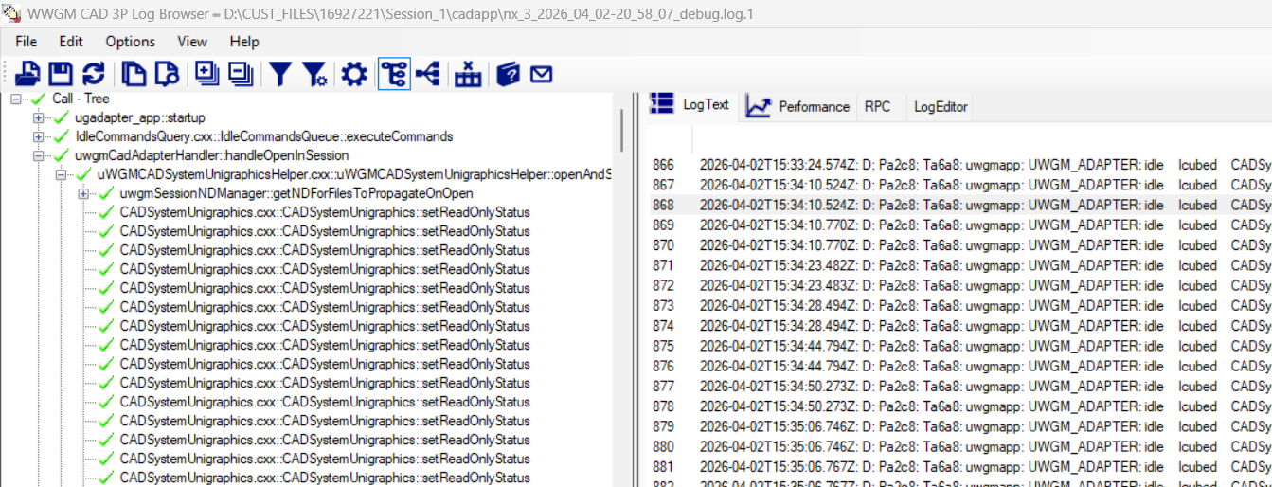

Call Tree Filtered
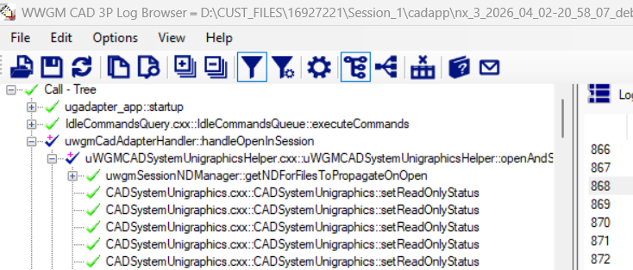

API Tree
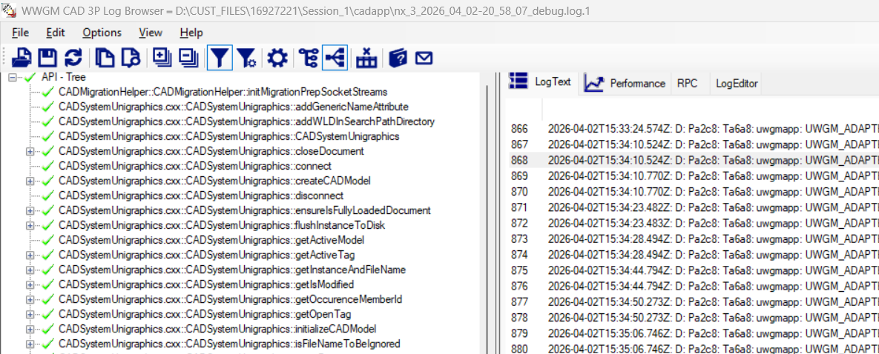
Tab View Panel
Default tab is LogText
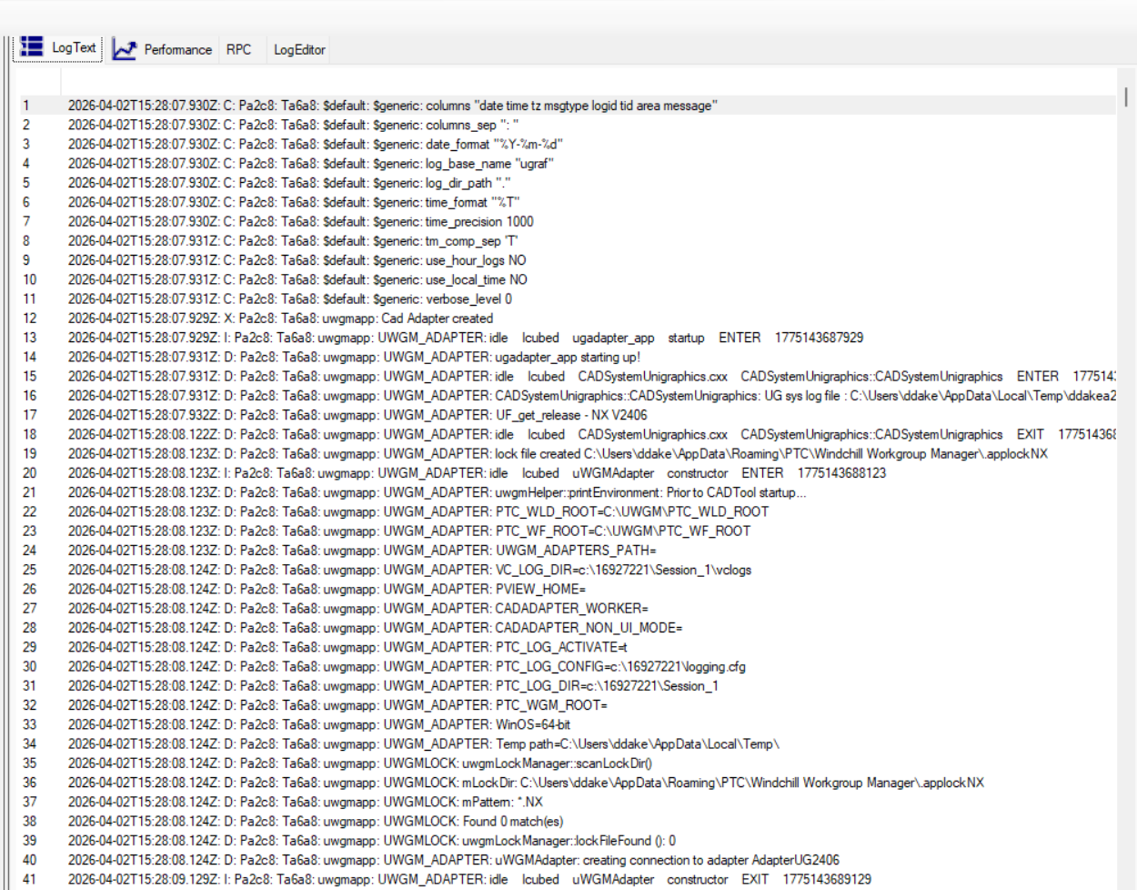

Perfomance Tab
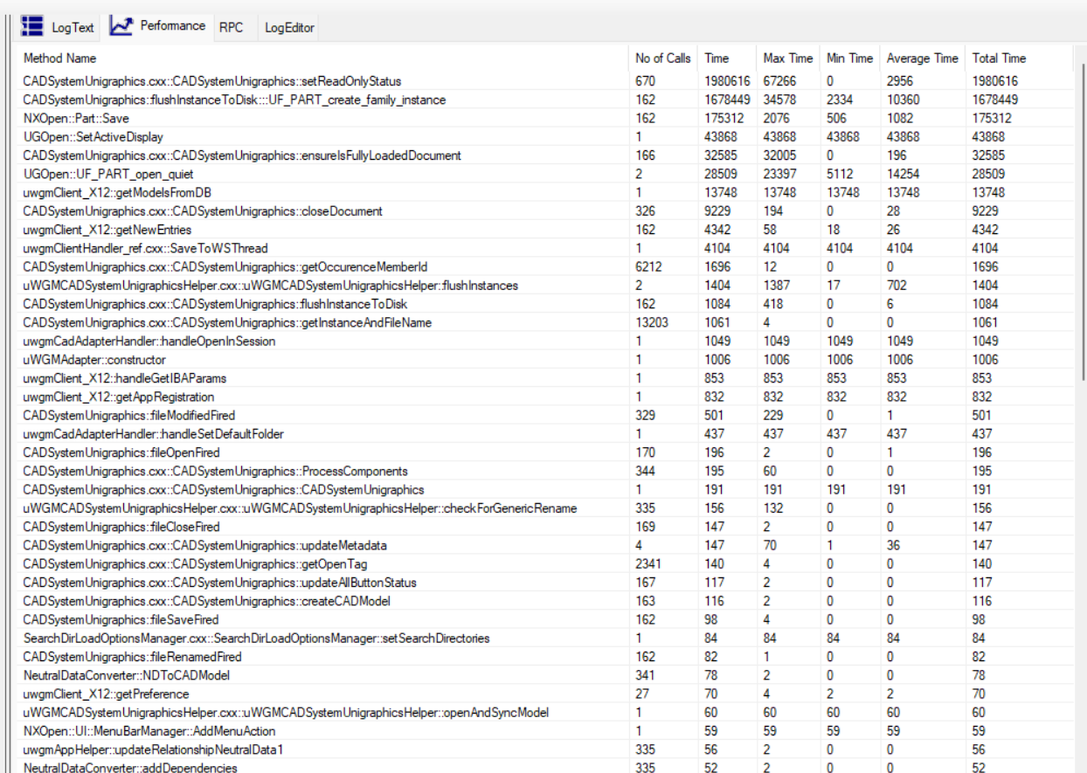

Filter Dialog
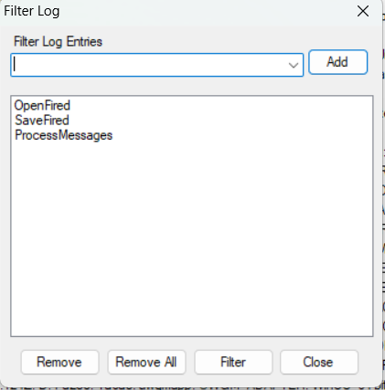

Settings Dialog
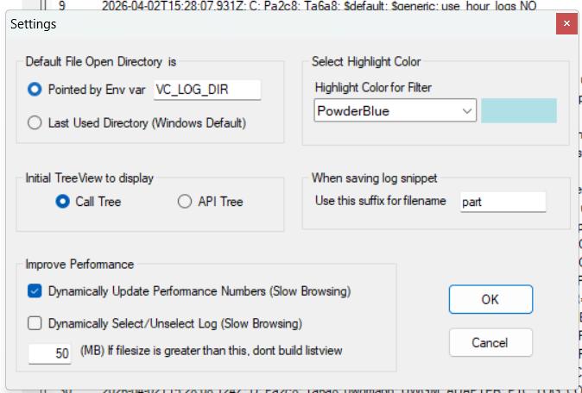

Report ErrorDialog
